Professor, please read this file to our lab activity fully functioning.

Import guide: <https://www.youtube.com/watch?v=jW5lrS6EUPM>

1. Download XAMPP and mySQL, any versions work, the latest version would suit the best.
2. Open XAMPP, start Apache and mySQL.

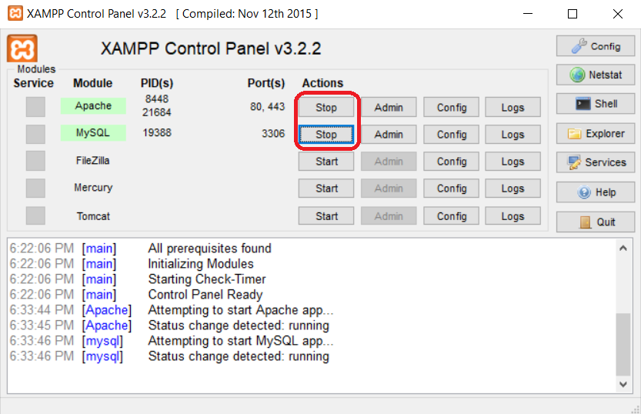

1. Download the zip we sent you, extract the zip.
2. Find and open the **xampp** folder, then inside the xampp folder, open the **htdocs** folder.

* This is usually the address: C:\xampp\htdocs

1. Download the zip that we sent you, then extract it to the **htdocs** folder.

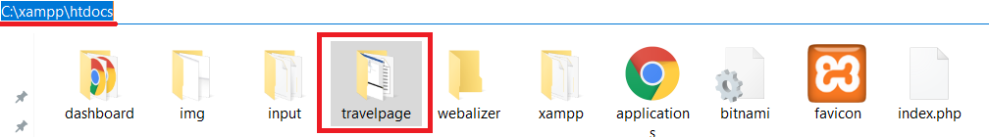

1. Go to the following page to find the index:
   * <http://localhost/travelpage>
2. Type the following address onto your address bar on any browser.
   * <http://localhost/phpmyadmin/>
3. Create a new database on the local host, called it **travelpage**. Go to travelpage on the side bar, then click on **Import** on the top menu. Find your travelpage folder that is inside the **htdocs** folder, select the **sql** folder. Click **Open**. Finally, click on **Go** button at the bottom of the Import page to complete importing the file.

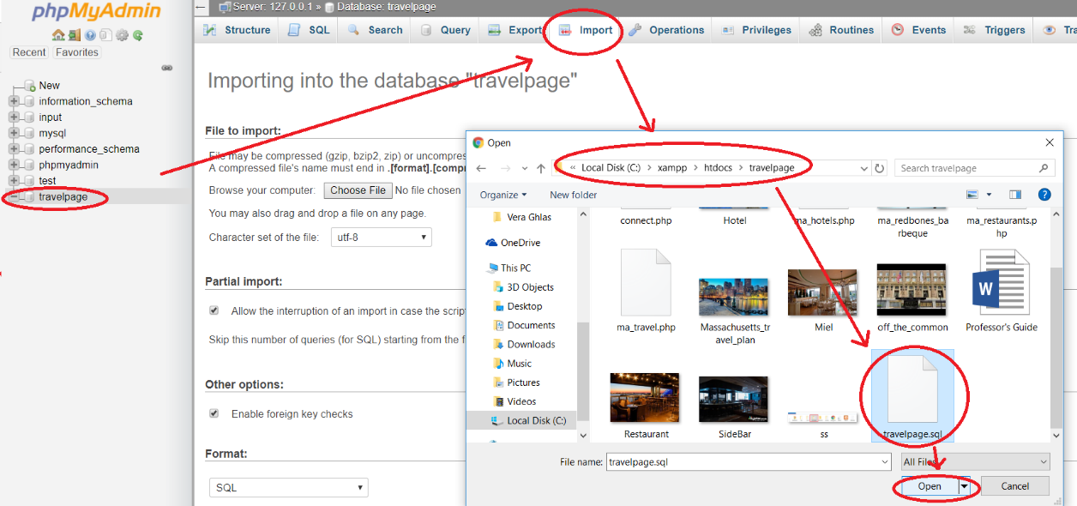

1. To test the database out, insert information you needed on one of the page. Here, we choose **InterContinental Boston**, it’s associated with to the database table called **hotel**.

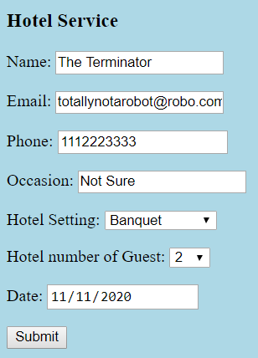

1. Check out whether the database is imported. Go to the **hotel** table of the travelpage database. Looks like it is inserted correctly!

